Enter the information and screenshot:

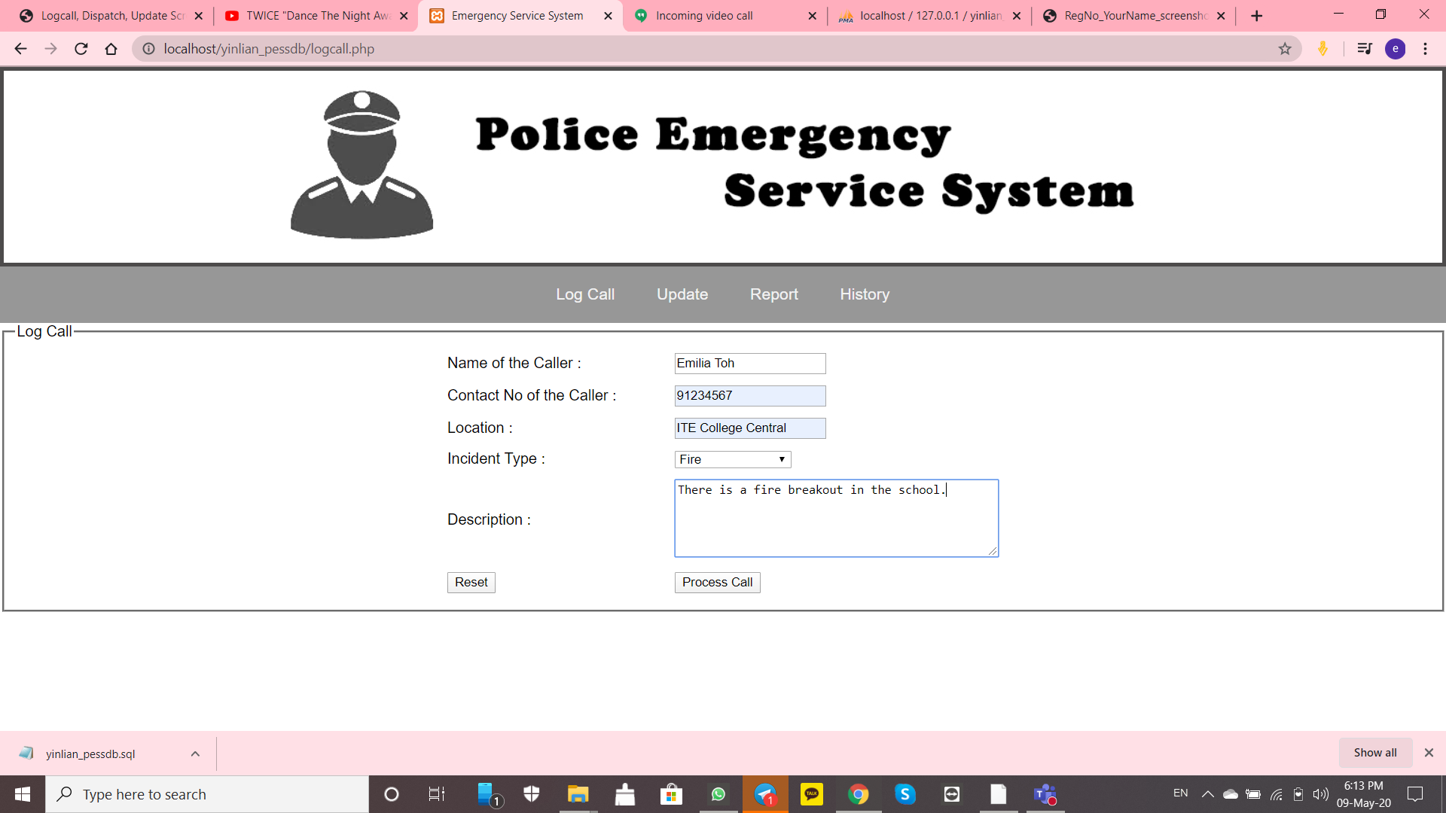

Screenshot the information before checking the checkbox:

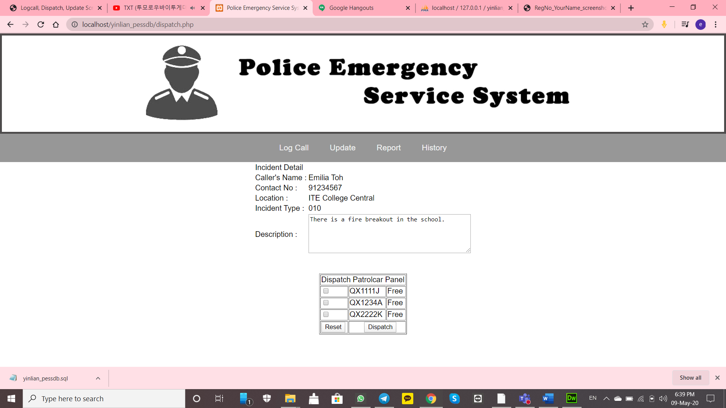

Dispatch Any Patrol Car, tick on the checkbox and screenshot:

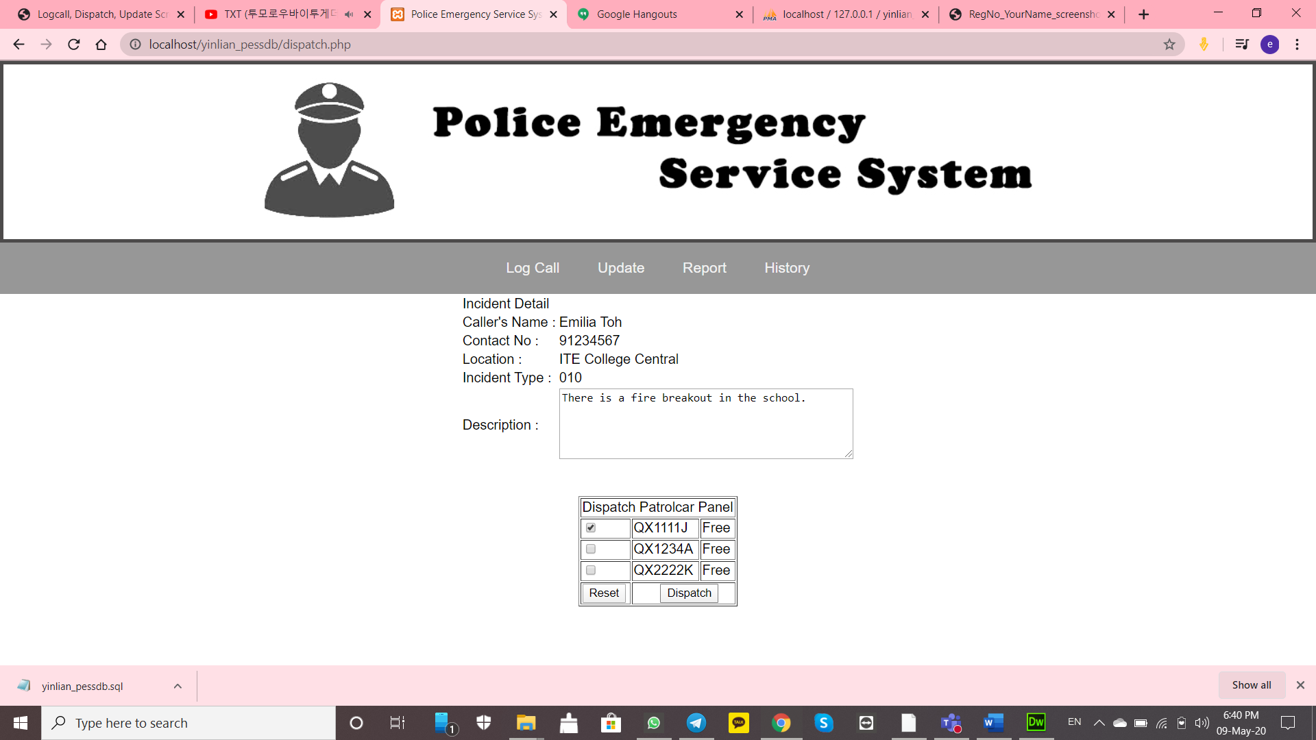

QX1111J being dispatched and disappear from the table:

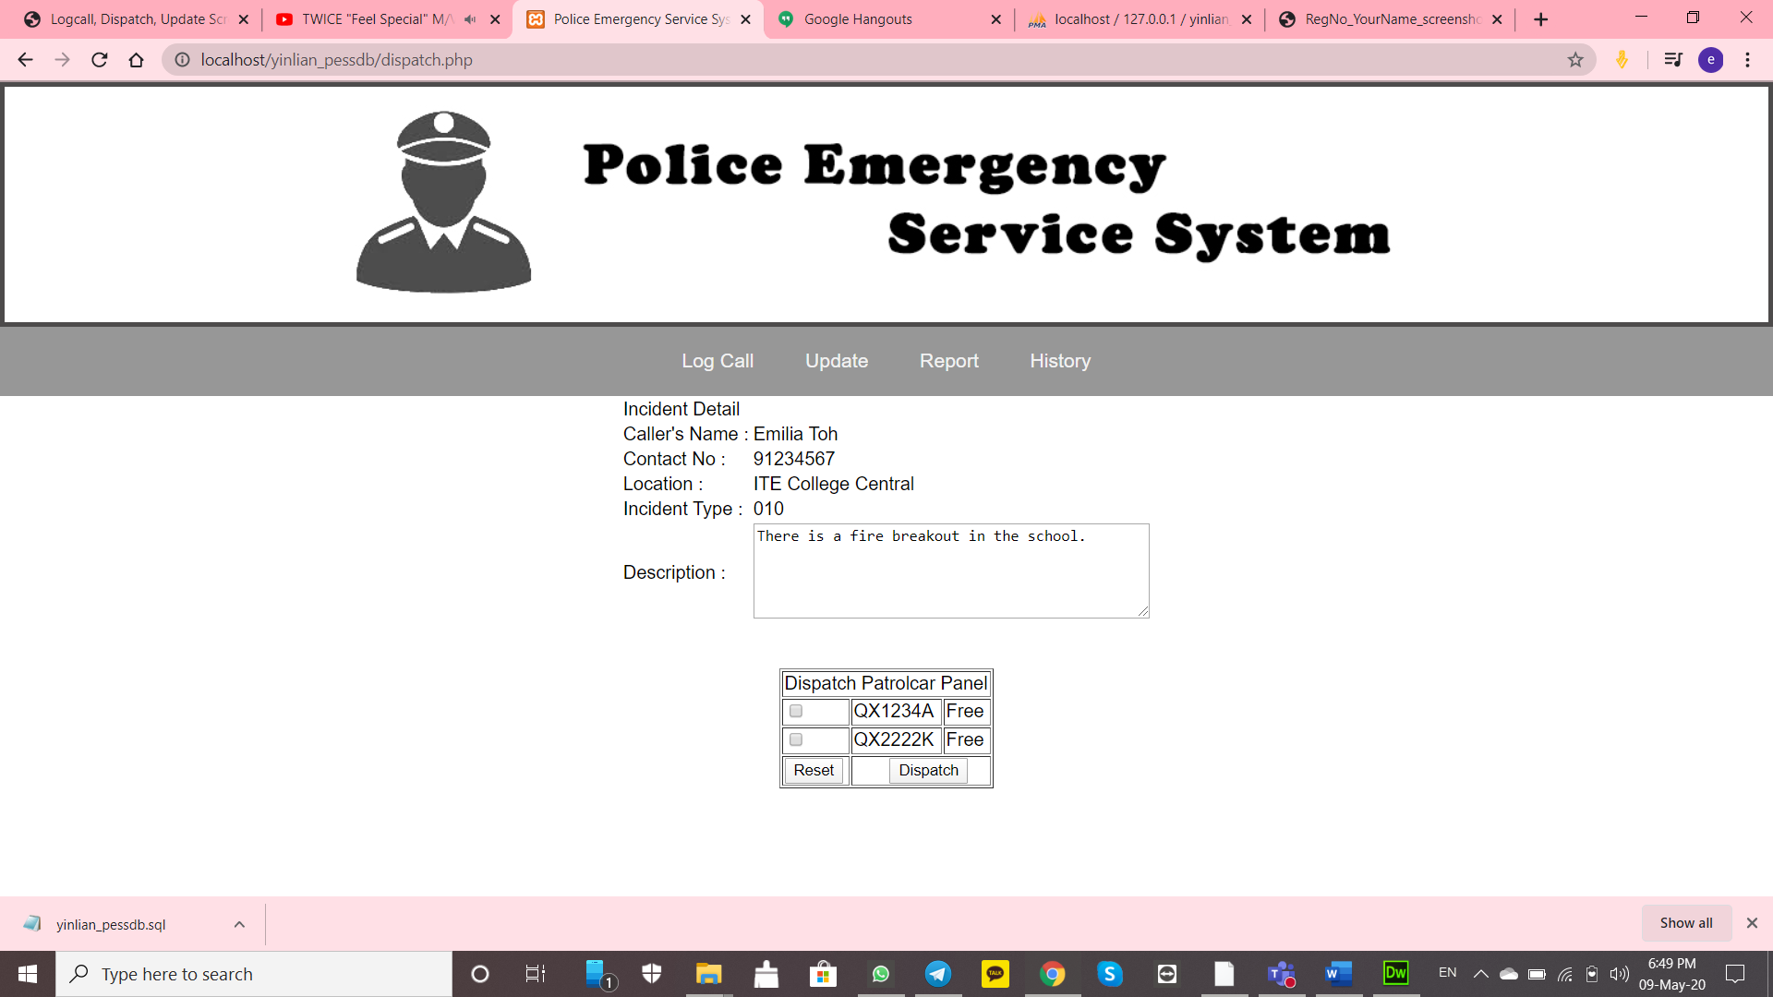

Caller’s Information appear in database from incident:

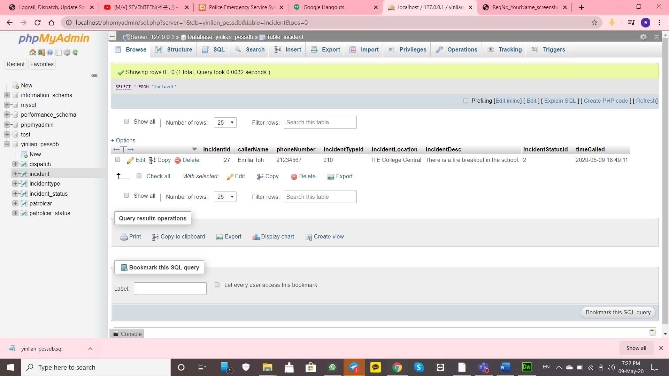

Check if QX1111J patrolcarStatusId is “1”

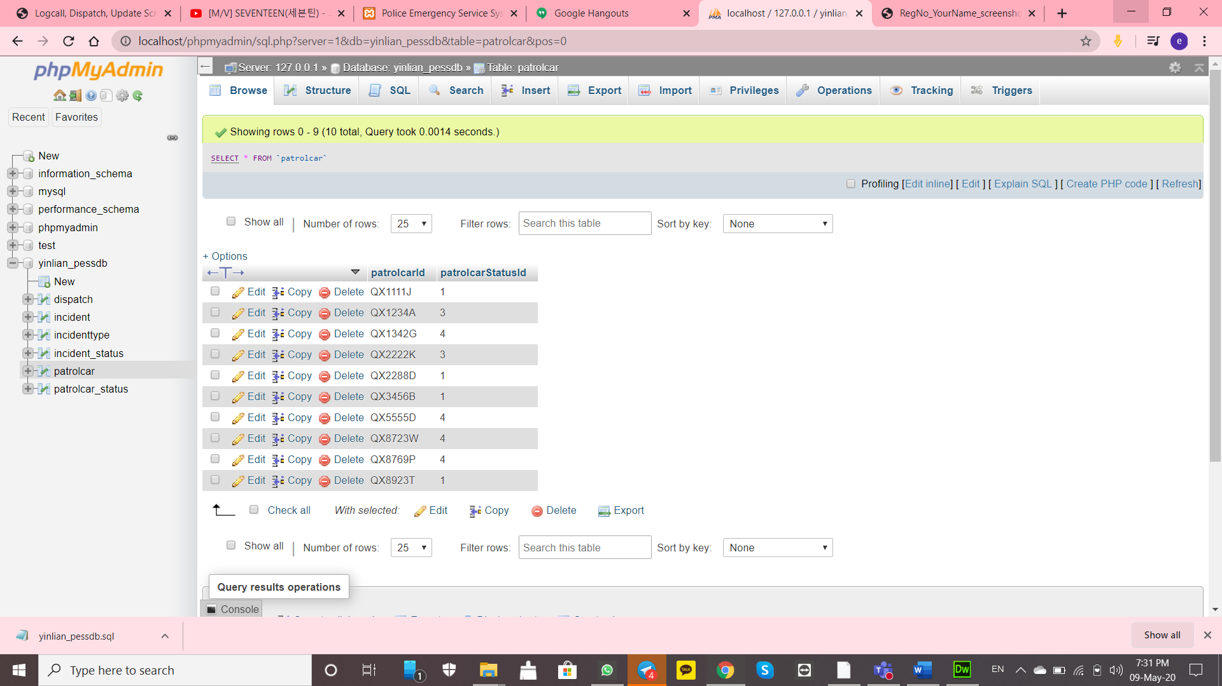

Check if the QX1111J timedispatched timing and the date is appearing in database:

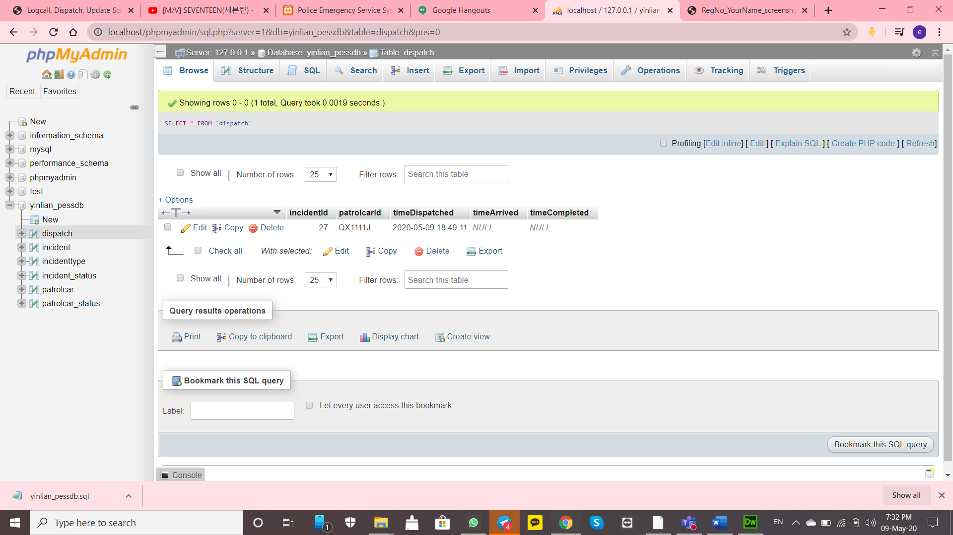

Type QX1111J and screenshot this before you search

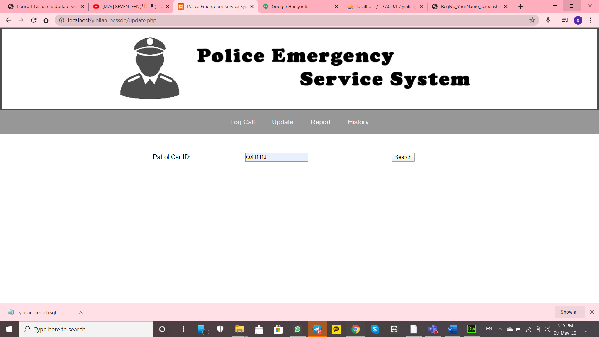

Screenshot this before you change anything

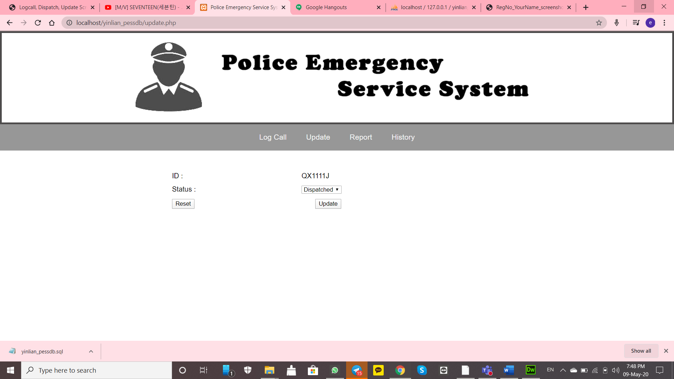

Change to Arrived and Screenshot it:

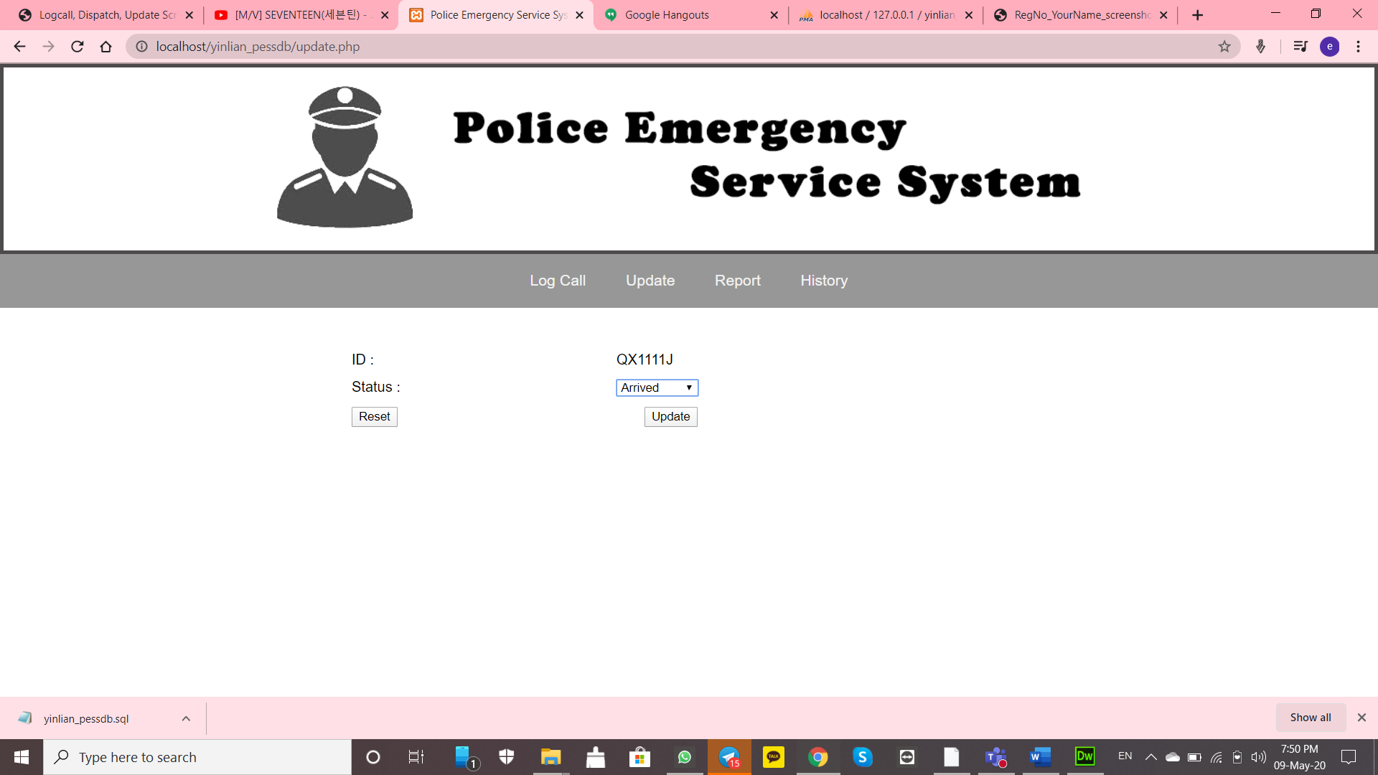

Go to dispatch and check the timeArrived timing and date appear here:

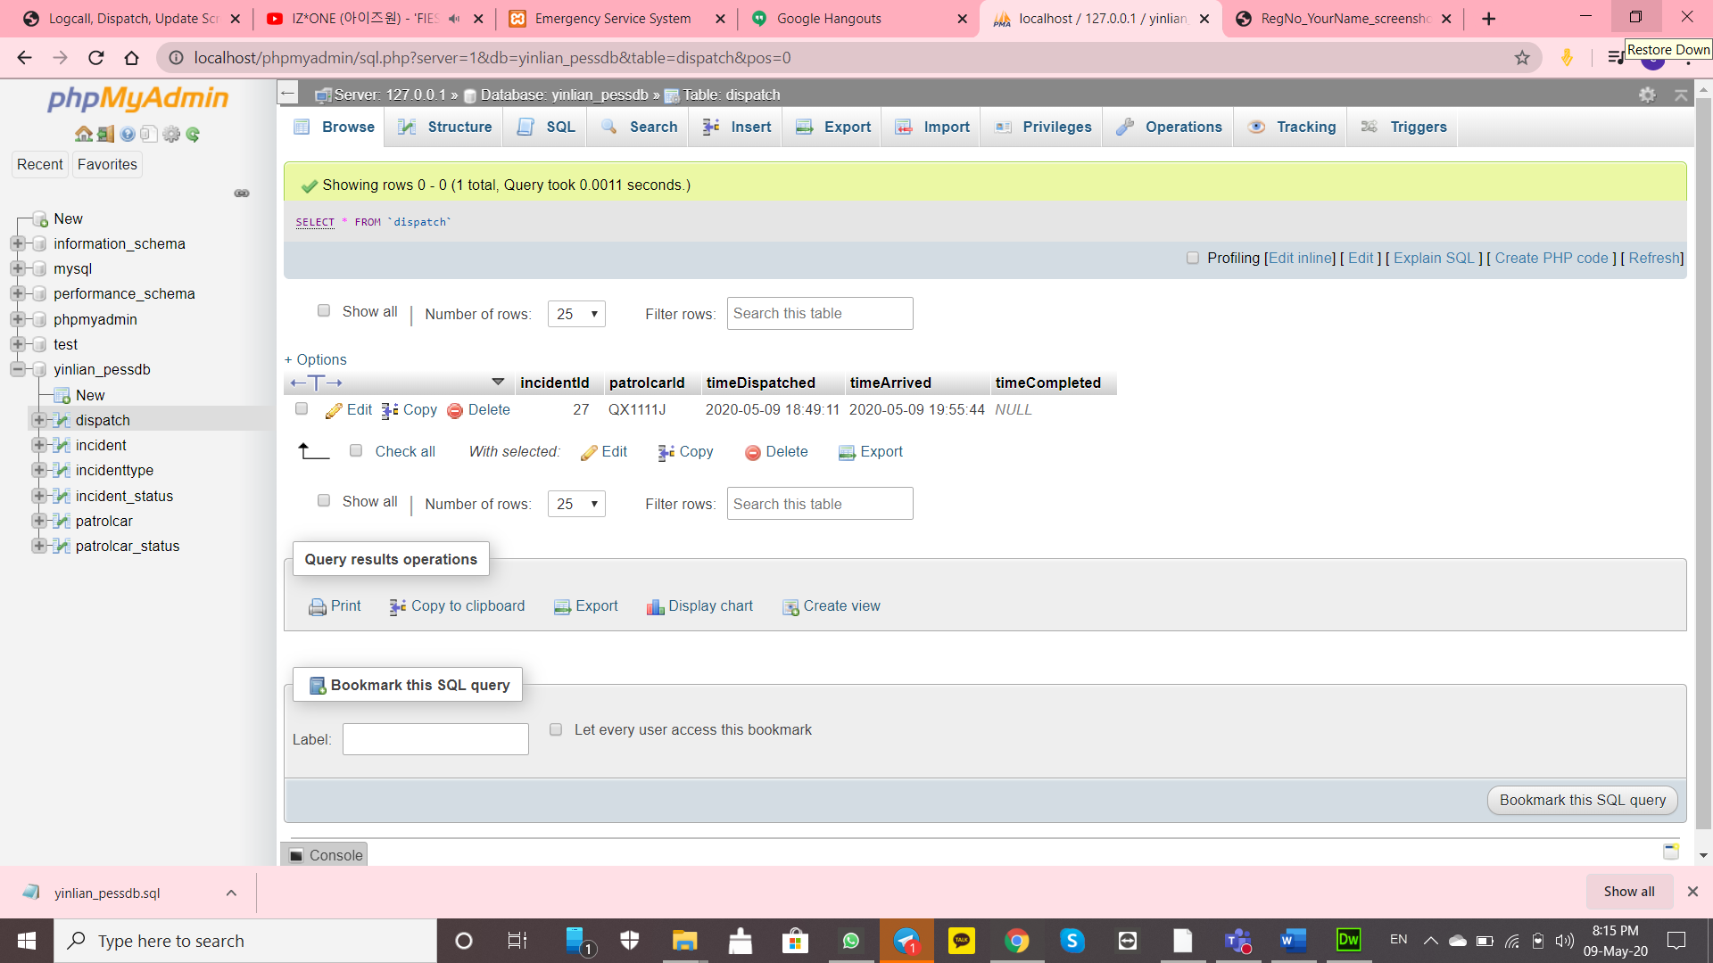

Screenshot this:

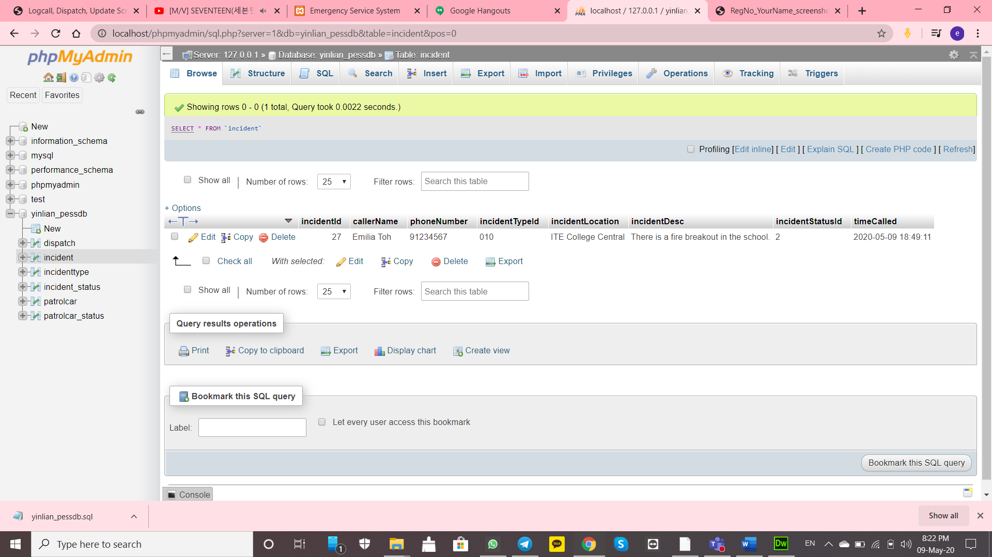

Check if the QX1111J patrolcarStatusId is 4 (Arrived)

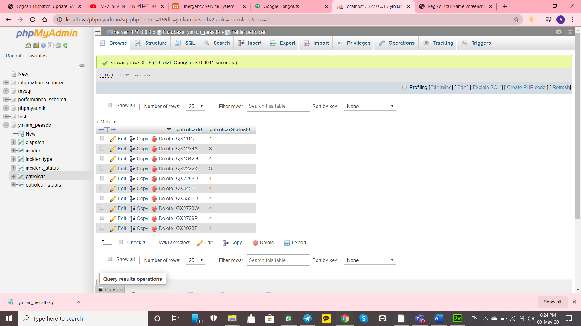

Type QX1111J and screenshot

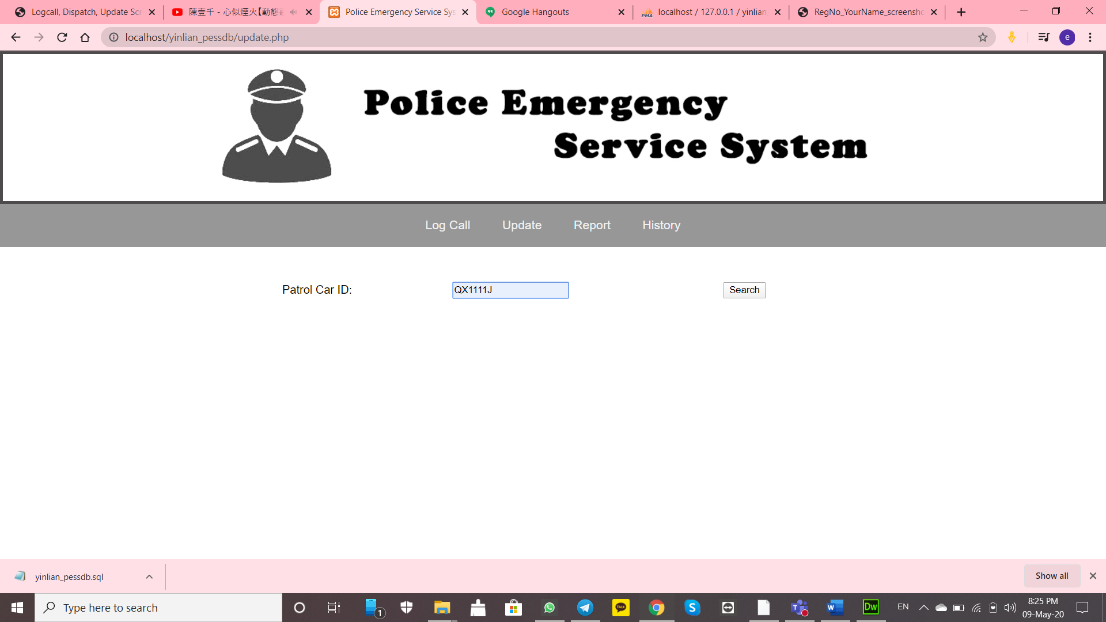

Screenshot This before you change anything:

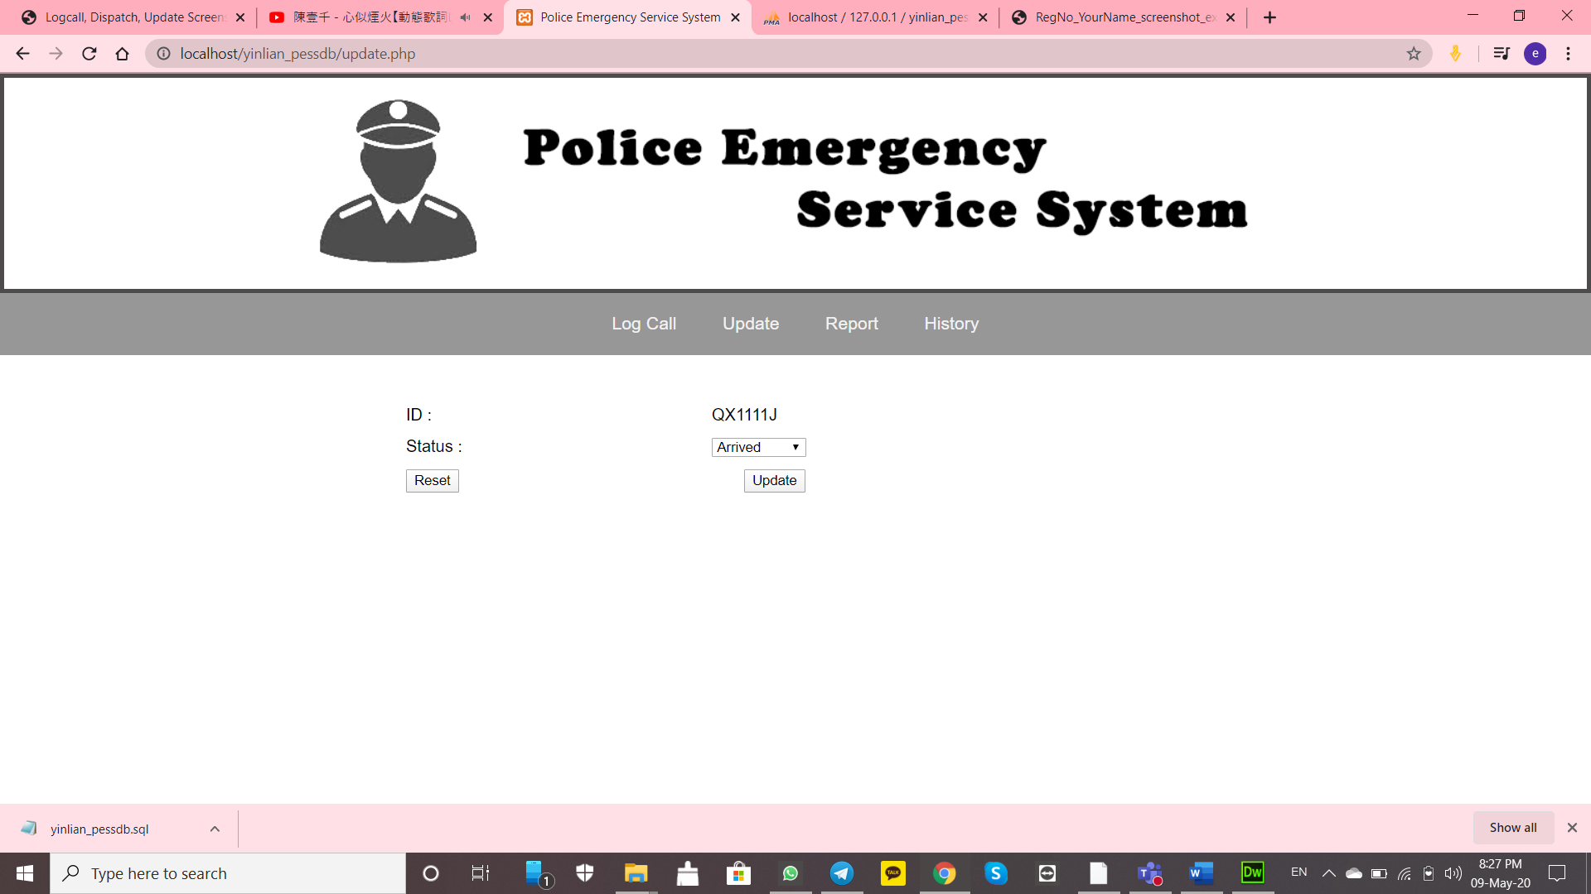

Change the status to Free and screenshot:

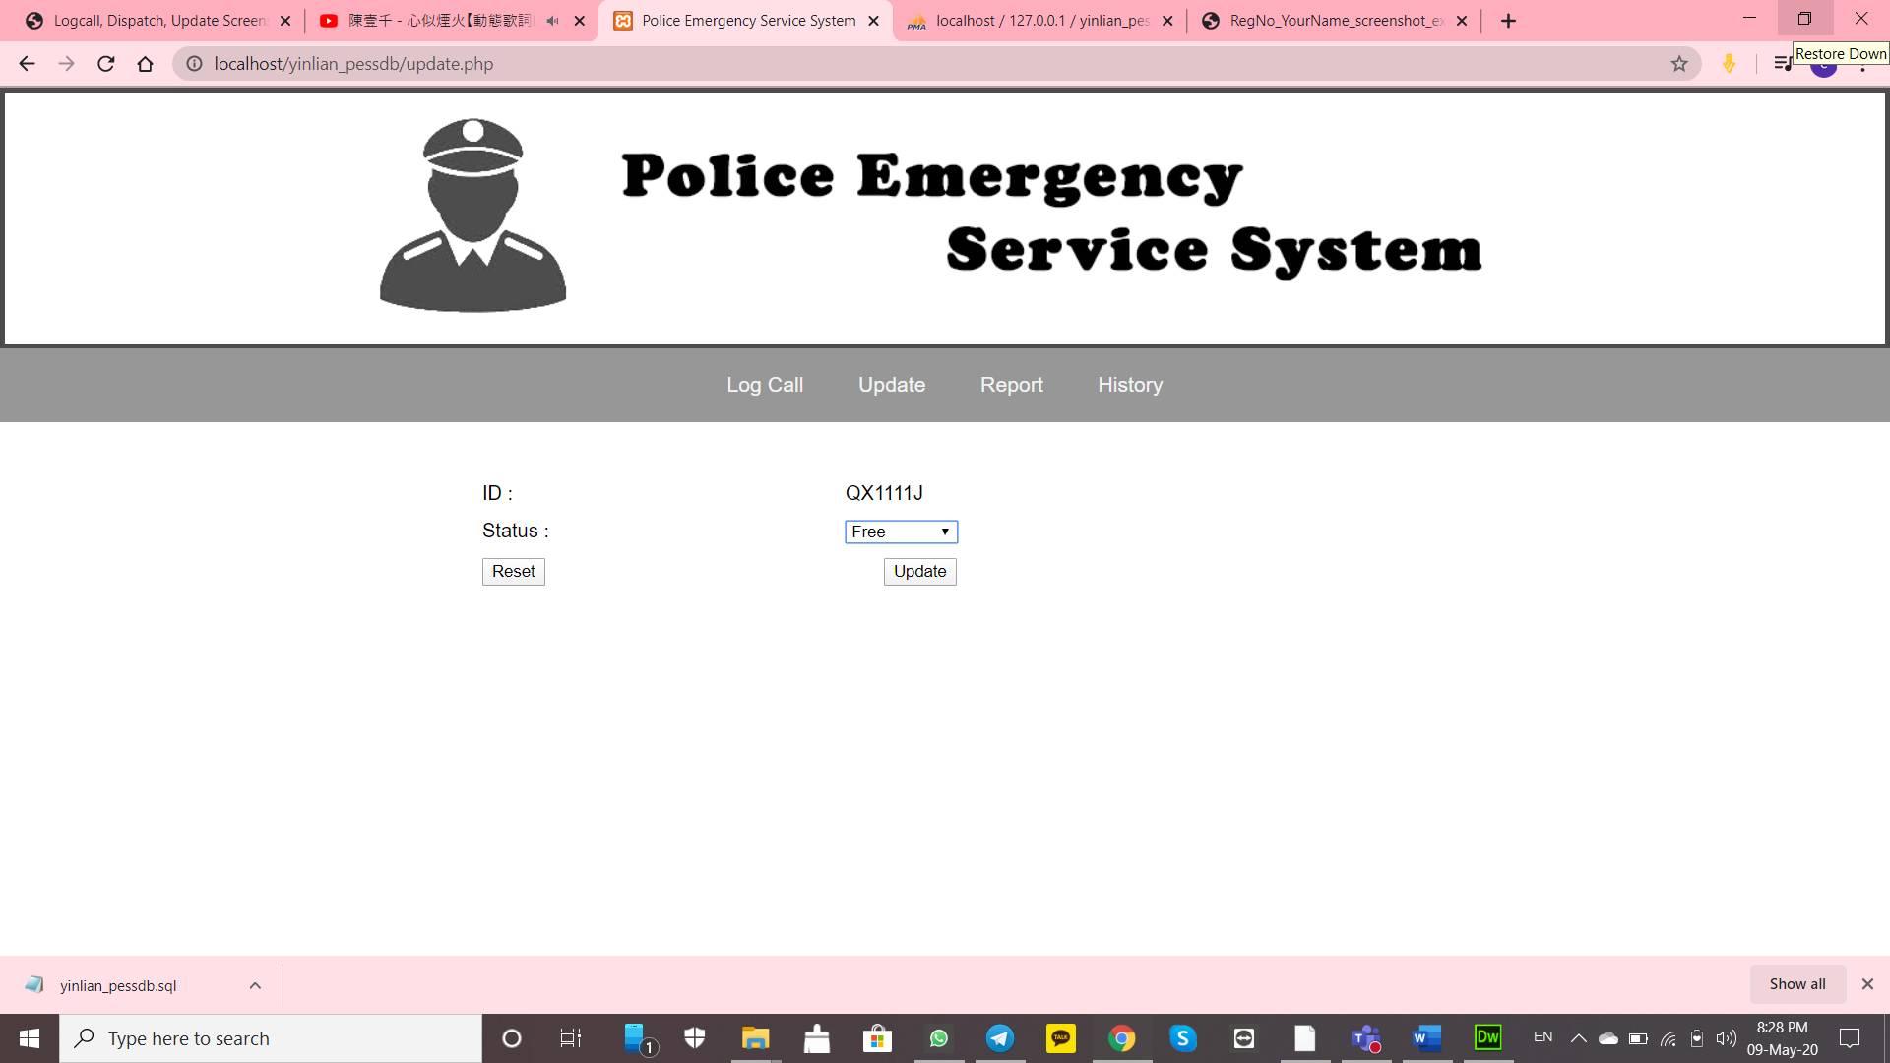

Check your dispatch if the timeCompleted timing and date is appearing

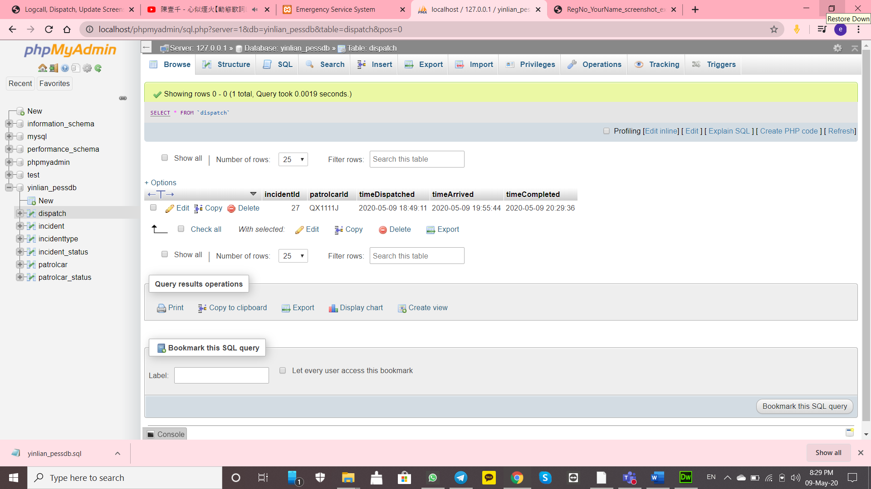

Check if your QX1111J patrolcarStatusId is “3” (Free)

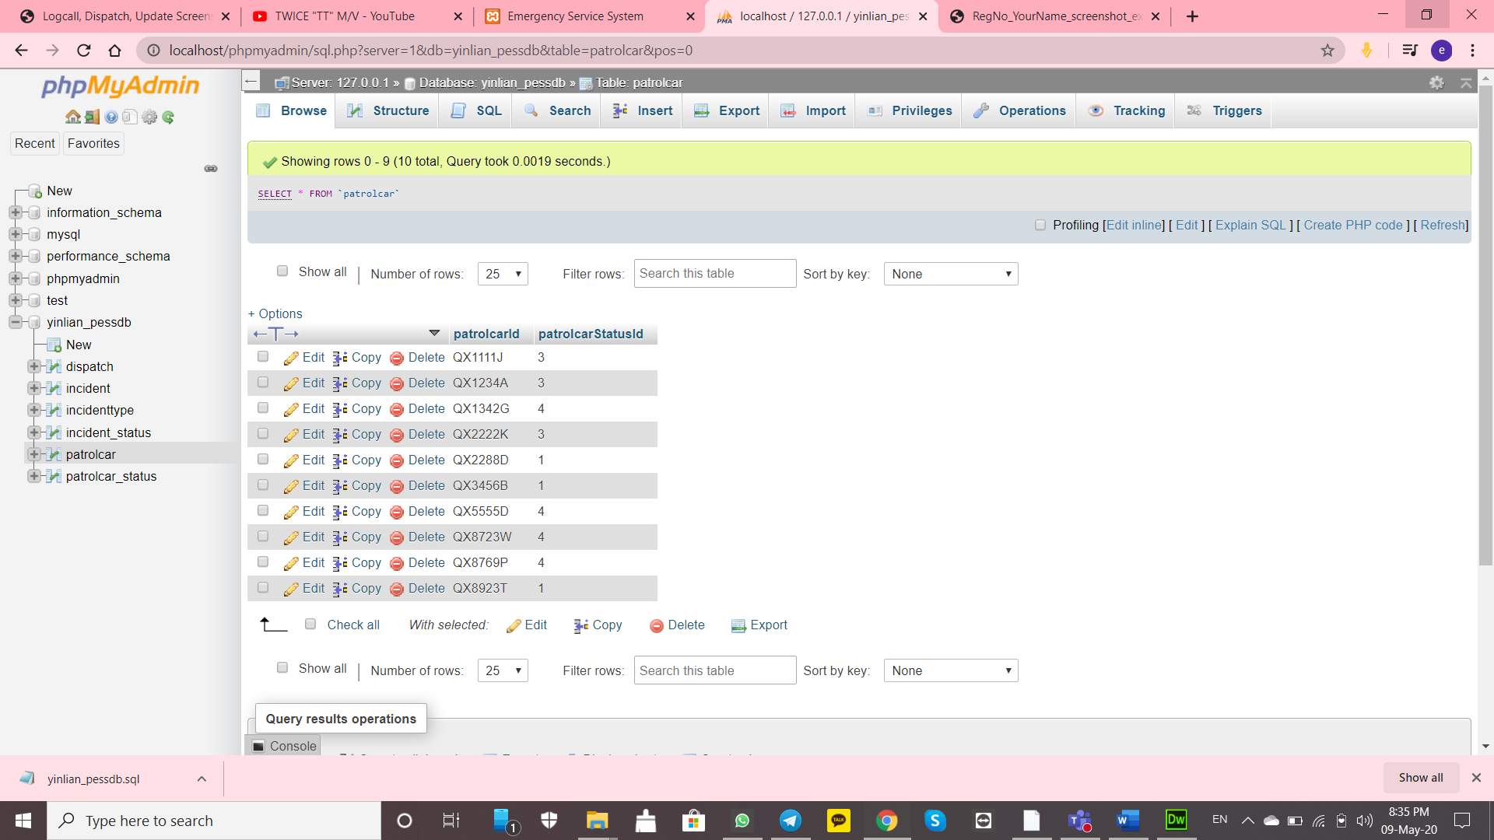

Screenshot this file location:

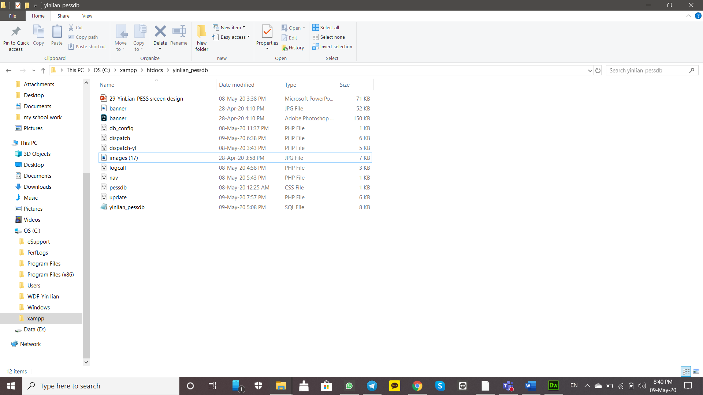

Screenshot yinlian_pessdb structure:

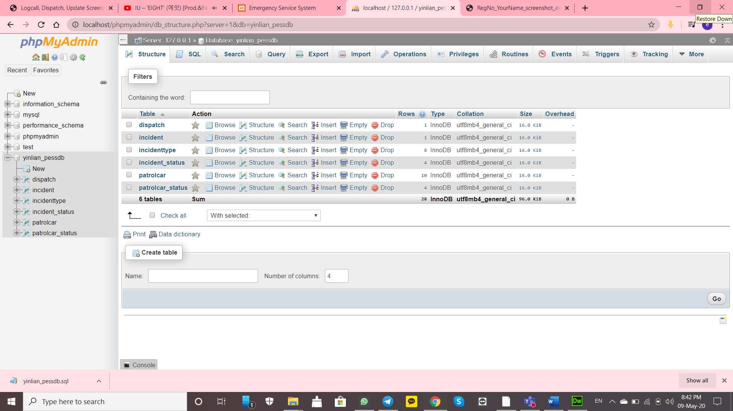

Screenshot dispatch browse:

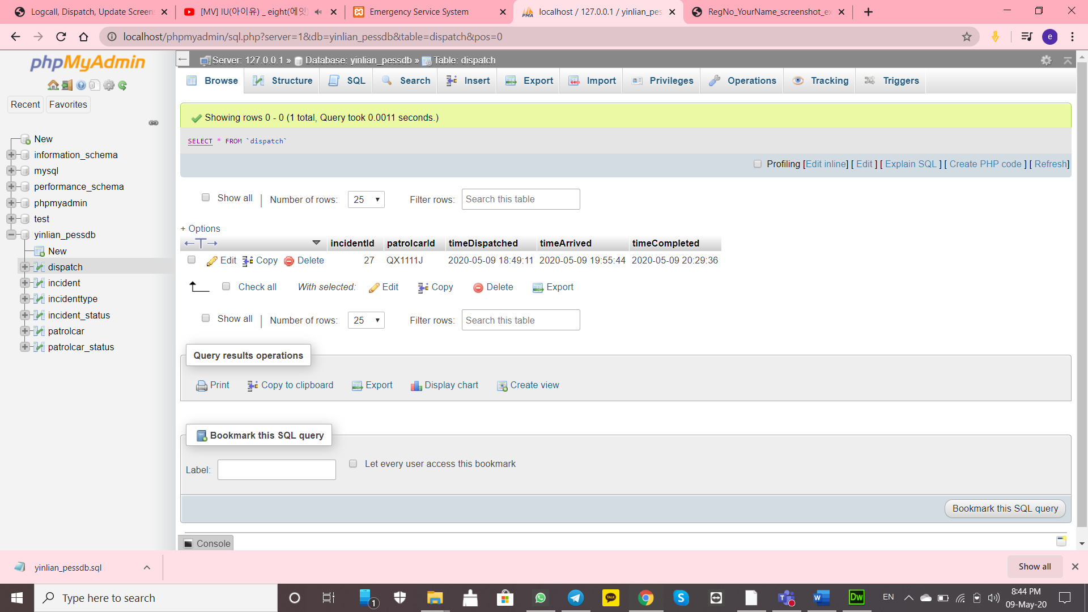

Screenshot dispatch structure:

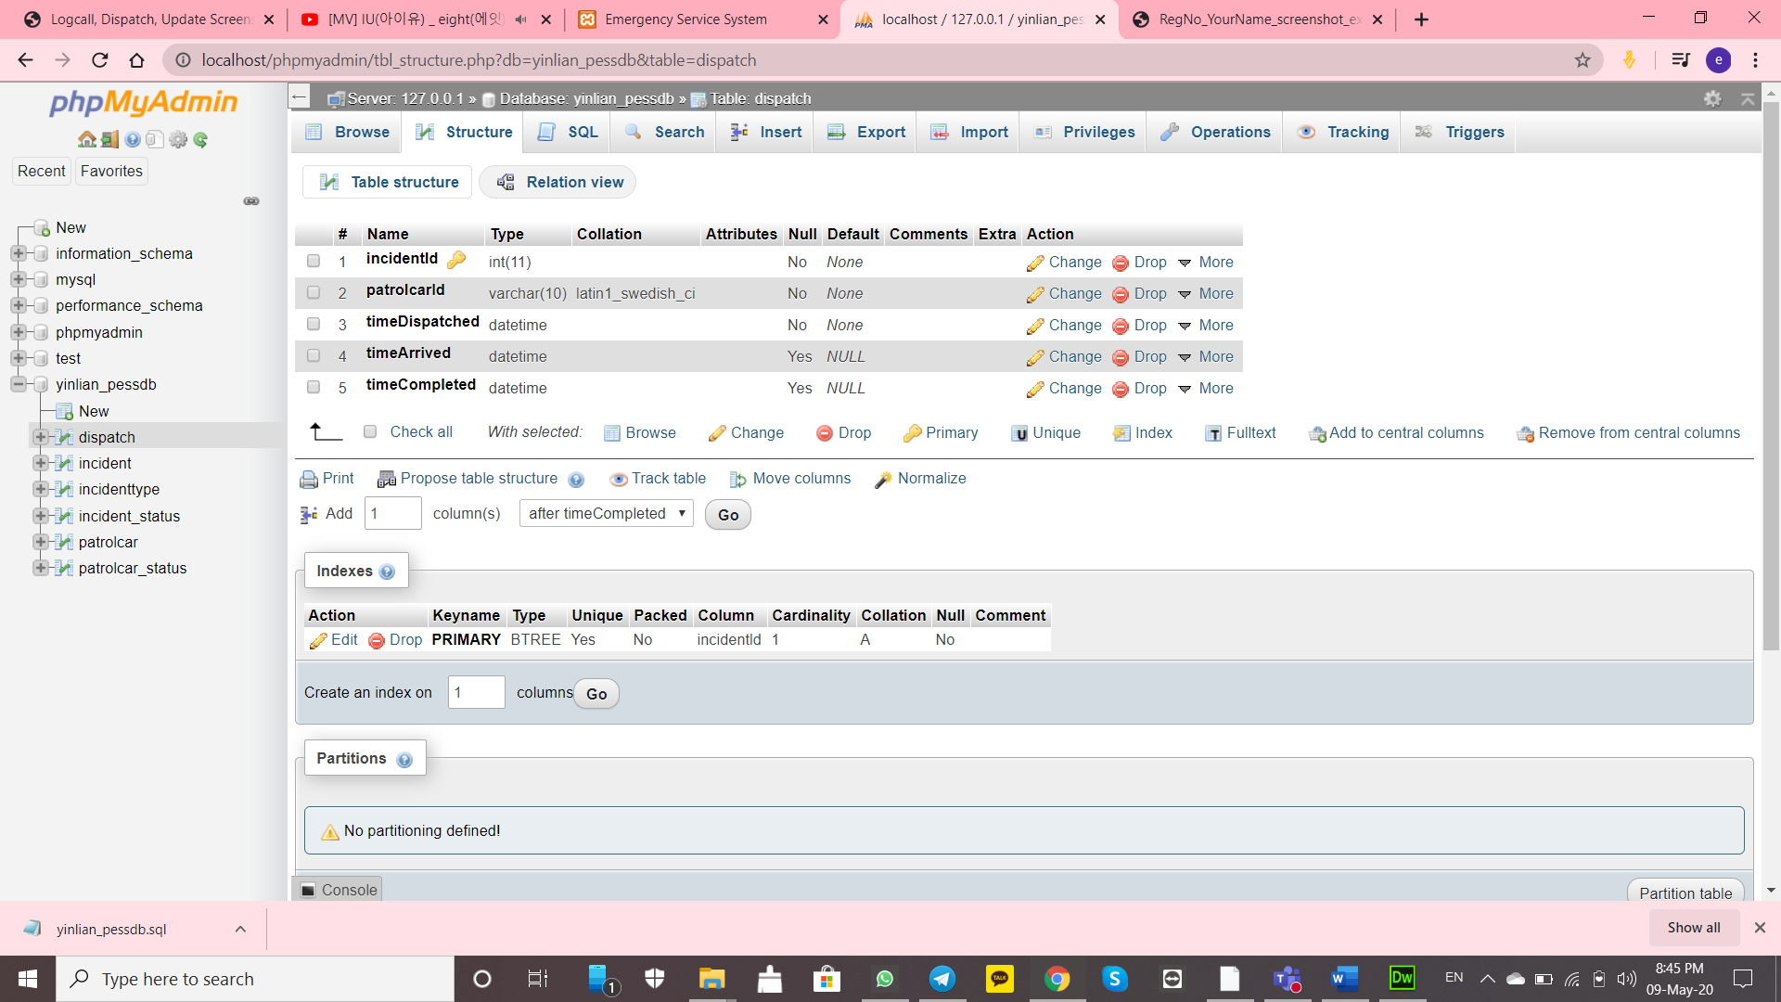

Screenshot incident browse:

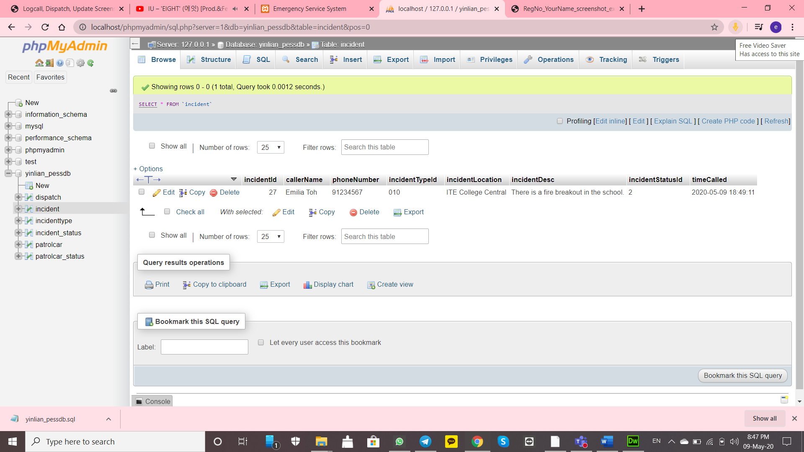

Screenshot incident structure:

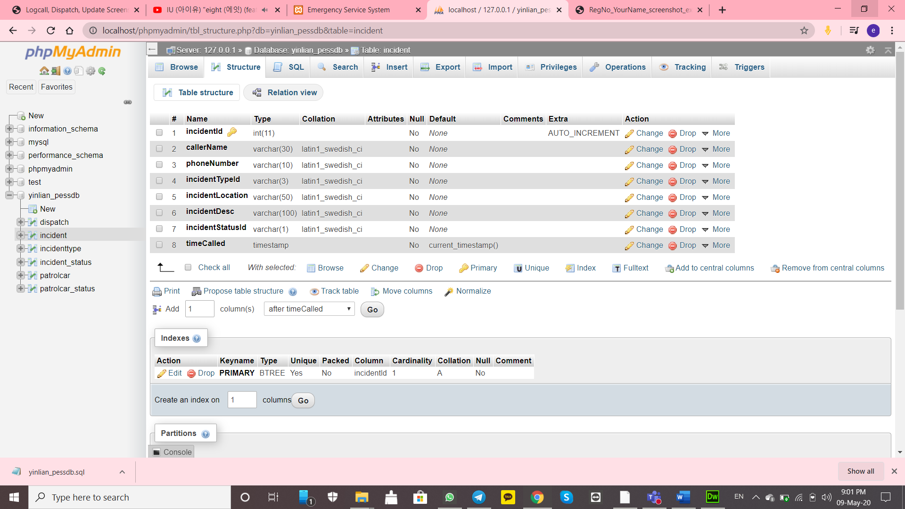

Screenshot incidenttype browse:

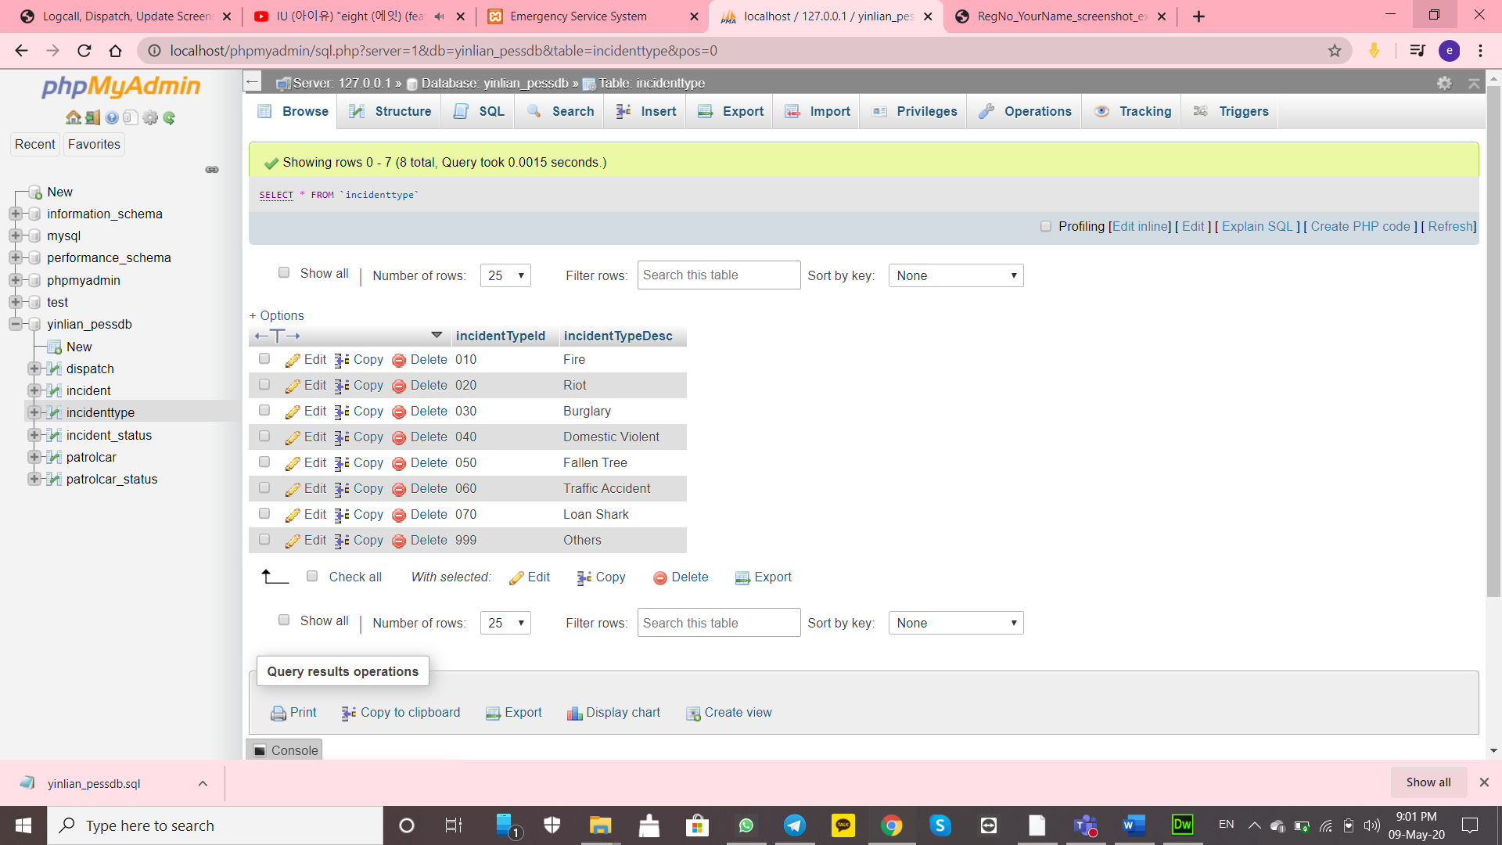

Screenshot incidenttype structure:

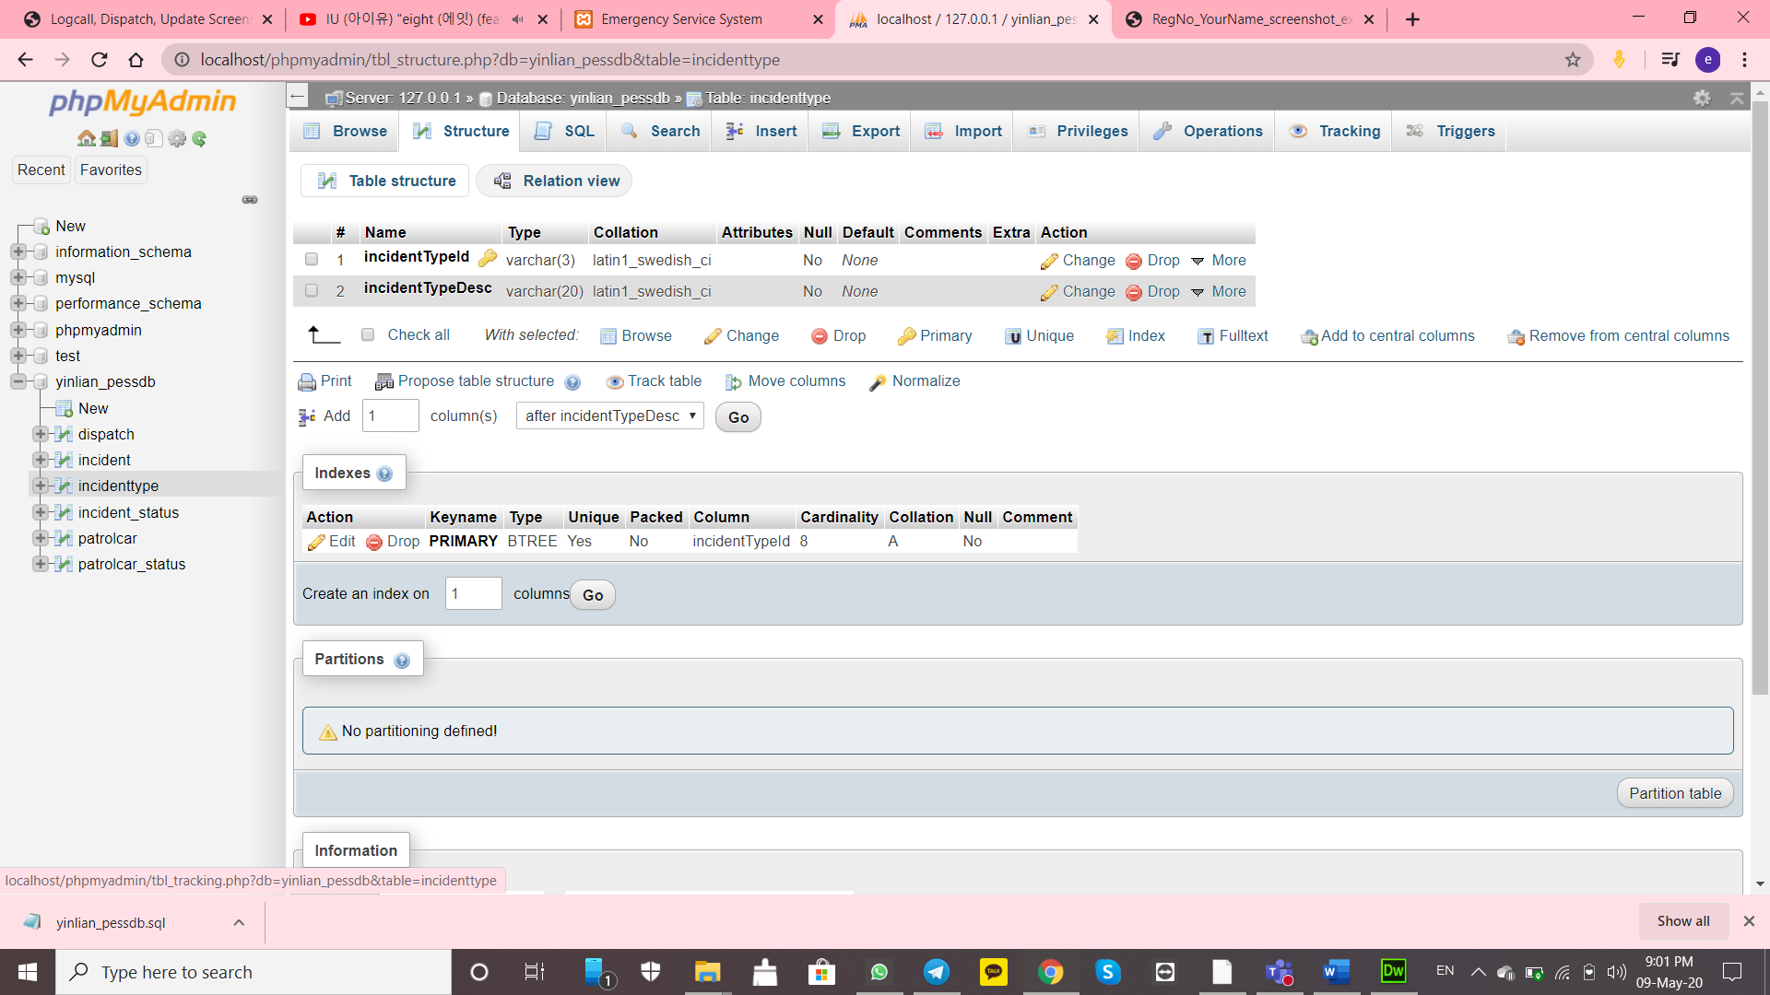

Screenshot incident_status browse:

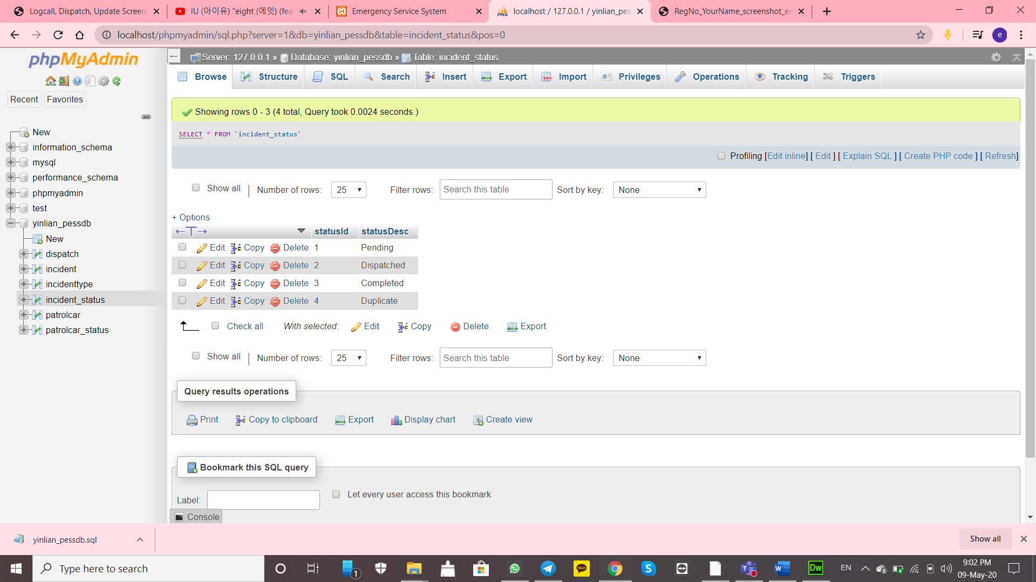

Screenshot incident_status structure:

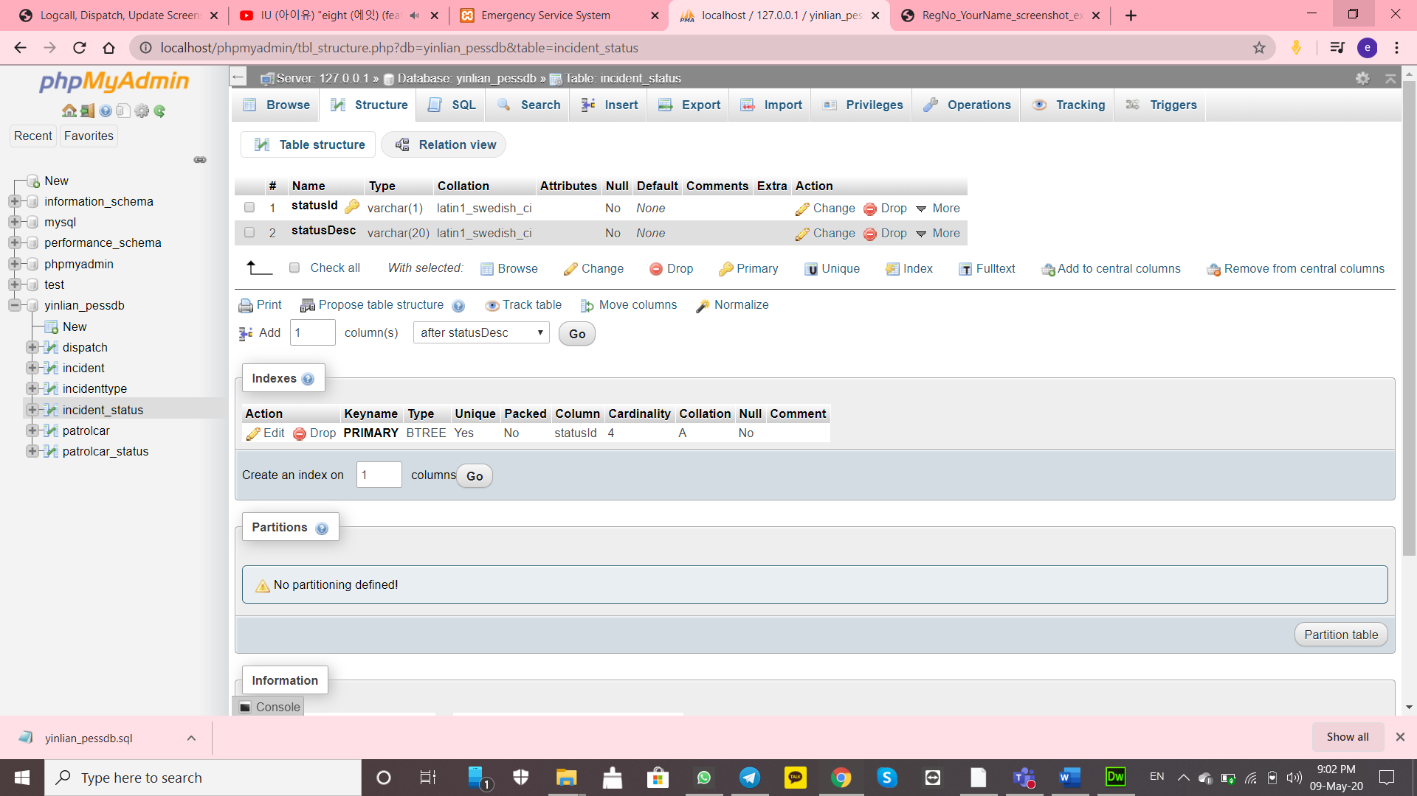

Screenshot patrolcar browse:

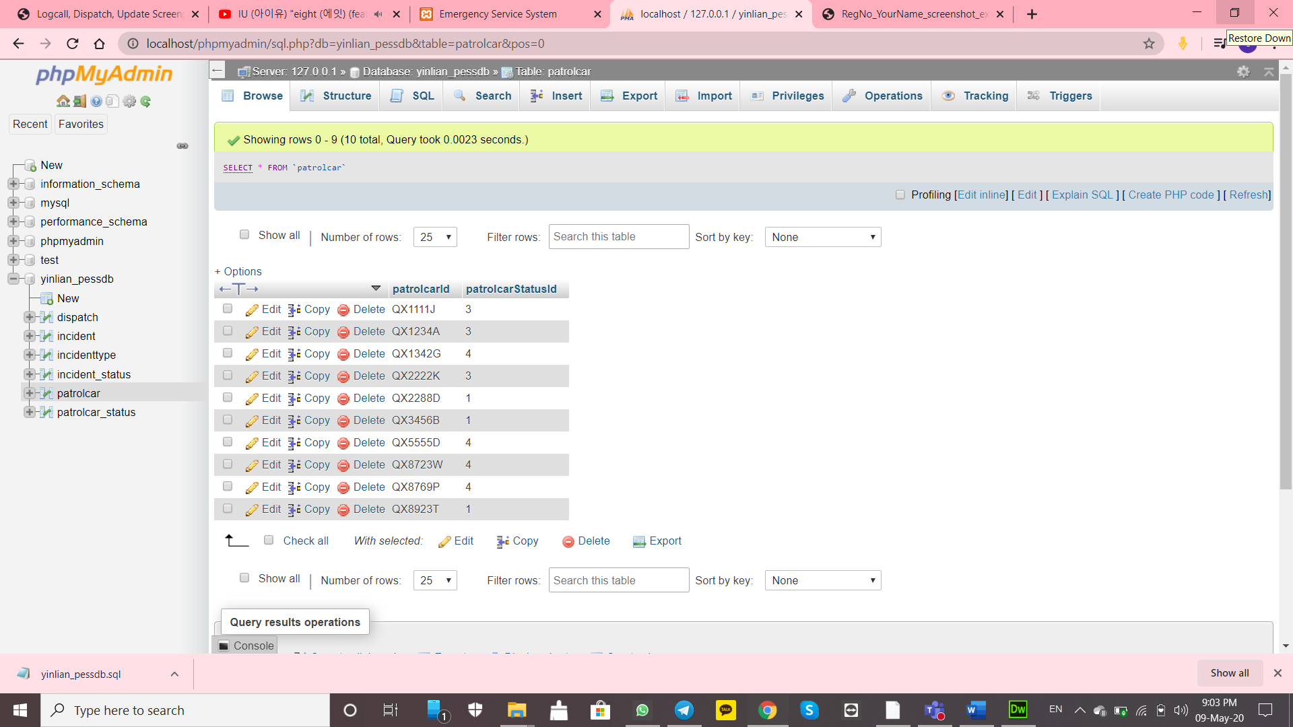

Screenshot patrolcar structure:

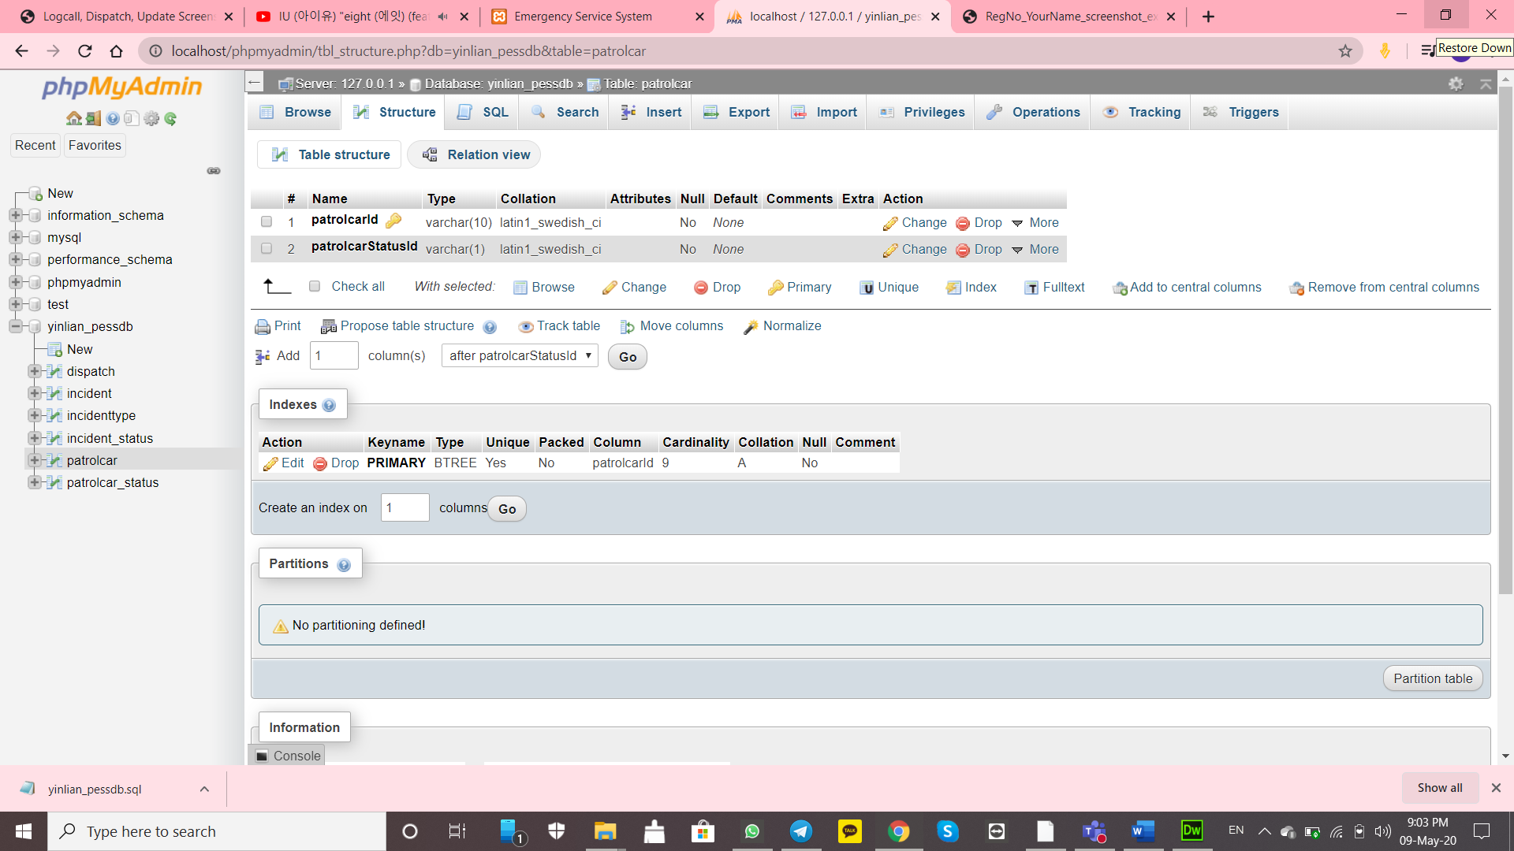

Screenshot patrolcar_status browse:

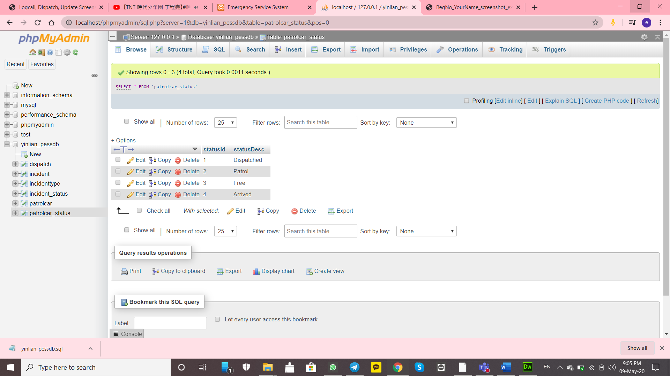

Screenshot patrolcar_status structure:

